**INTEGRATOR USING IC741 OP-AMP**

**Objective**

To study the operation of the Integrator using op-amp and trace the output wave forms for sine and square wave inputs.

**THEORY**

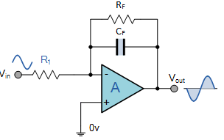  
**Figure 1**

A circuit in which the output voltage is the integration of the input voltage is called an integrator.

$$V_{o}=-\frac{1}{R_{1}C_{F}}\int{V_{in}}dt$$

In the practical integrator shown in Figure 1, to reduce the error voltage at the output, a resistor RF is connected across the feedback capacitor CF. Thus, RF limits the low-frequency gain and hence minimizes the variations in the output voltage.

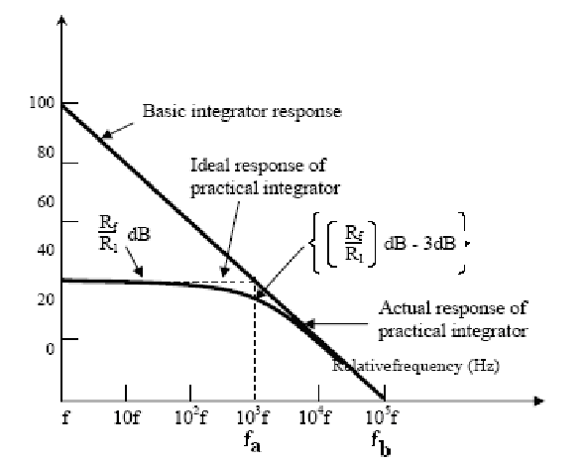

**Figure 2**

The frequency response of the integrator is shown in Figure 2. fb is the frequency at which the gain is 0 dB and is given by:

fb = 1/2πR1CF

In this figure there is some relative operating frequency, and for frequencies from f to fa the gain RF/R1 is constant. However, after fa the gain decreases at a rate of 20 dB/decade. In other words, between fa and fb the circuit of fig. 2.1 acts as an integrator. The gain limiting frequency fa is given by

fa=1/2πRFCF.

Normally fa<fb. From the above equation, we can calculate RF by assuming fa & CF. This is very important frequency. It tells us where the useful integration range starts.

* If fin < fa - circuit acts like a simple inverting amplifier and no integration results,
* If fin = fa - integration takes place with only 50% accuracy results,
* If fin = 10fa - integration takes place with 99% accuracy results.

In the circuit diagram of Integrator, the values are calculated by assuming fa as 50 Hz. Hence the input frequency is to be taken as 500Hz to get 99% accuracy results. Integrator has wide applications in

1. Analog computers used for solving differential equations in simulation arrangements.
2. A/D Converters.
3. Signal wave shaping.
4. Function Generators.

**Equipment:**

1. Oscilloscope
2. AC Function Generator
3. Digital Multimeter

**Components:**

1. Resistors: 10kΩ, 22kΩ
2. Capacitor 0.1µF
3. Op-amp 741

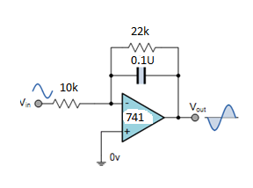

**Figure 3**

**PROCEDURE:**

1. Connect the components/equipment as shown in the circuit diagram Figure 3.
2. Switch ON the power supply.
3. Apply sine wave at the input terminals of the circuit using function Generator.
4. Connect channel-1 of CRO at the input terminals and channel-2 at the output terminals.
5. Observe the output of the circuit on the CRO which is a cosine wave (90o phase shifted from the sine wave input) and note down the position, the amplitude and the time period of Vin & Vo.
6. Now apply the square wave as input signal.
7. Observe the output of the circuit on the CRO which is a triangular wave and note down the position, the amplitude and the time period of Vin & Vo.
8. Plot the output voltages corresponding to sine and square wave inputs as shown in the Figure 4 below.

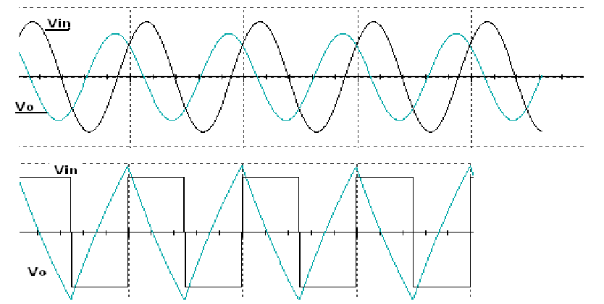

**Figure 4**